

**MASTER THESIS**

|  |
| --- |
| **TITLE: Master thesis template (Title)**  **MASTER DEGREE: [insert master’s degree name here]**  **AUTHOR: Josep Mª Acosta Pérez (name of the student)**  **ADVISOR: José González González (name of the advisor or co-advisors)**  **DATE: September, 23rd 2014 (date of the last version of the document)** |

|  |
| --- |
| **Title:** Master Thesis template  **Author:** Manuel Pérez Pérez  **Advisor:** José González González  **Date:** September 23, 2014 |

**Abstract**

|  |
| --- |
| This document contains guidelines on the format of the master thesis document.  In this section you have to fill the box (only this page) with a high level summary of the topic of the master thesis: what field have you been working on, why what you have done is relevant, what have you done, how, and results. |

**CONTENTS**

INTRODUCTION 1

CHAPTER 1. layout 2

1.1. Paper and printing 2

1.1.1. paper 2

1.1.2. Print on both sides 2

1.2. margins 2

1.3. typography 2

1.3.1. Fonts 2

1.3.2. spacing 3

1.4. Numbering titles 3

1.5. Headings and page numbers 3

1.6. binding 3

CHAPTER 2. ORGANIZATION OF WORK 4

2.1. preliminary pages 4

2.1.1. Home 4

2.1.2. Summary 4

2.1.3. dedication 4

2.1.4. Index 5

2.2. Body of work 5

2.2.1. Introduction 5

2.2.2. Preparation of the chapters 6

2.2.3. Formulas, figures and tables 6

2.2.4. Sustainability Study 7

2.3. Bibliography 8

2.4. annexes 8

# INTRODUCTION

The purpose of this document is to provide guidelines for the master thesis. This document is itself an example of such a document.

In this section you should prepare a couple of pages, or a bit more with an extended version of the abstract: what field have you been working on, why what you have done is relevant, what have you done, how, and results. End the chapter describing the organization of the document, as follows:

The remainder of the document is organized as follows. The first chapter presents the topic and the instructions concerning the presentation, i.e. font, paper, margins, headings, numbering and others. Chapter 2 focuses on...

CHAPTER 1. LAYOUT

## Paper and printing

### Paper

A4 paper should be used upright (210 x 297 mm). Besides being the most widespread standard, it is the default format for most word processors.

### Print on both sides

If printed, the document should be printed on both sides from Introduction until the end of the document. If you are able to and do not violate the total length requirements, try to start the chapters on odd (non-even) pages.

## Margins

The margins to be used are:

* superior: 2,5 cm
* Lower: 2,5 cm
* Law: 3 cm
* left: 3 cm

## Typography

### Fonts

* Base font: Arial 12
* Font chapters (Title 1): Arial 16, bold, centred
* Font paragraphs (Title 2): Arial 14, bold, left-aligned
* Font for subsections (Title 3): Arial 13, bold, left-aligned
* Fonts sections of subsections (Title 4): Arial 12, italic, left-aligned
* Font for headings: Arial 8, underlined
* Font for the page numbers: Arial 8, underlined

### Spacing

* Single paragraph in the body
* Add a blank line between each paragraph
* Add a blank line between the title of the section and the beginning of the text

## Numbering titles

* Numbering of the chapters: in Arabic numbers
* Numbering sections: Arabic number refers to the chapter, followed by a period, and the number of Arab section followed by a period.
* Numbering of the sections: Arabic number refers to the chapter, followed by a period, the number refers to the Arabic section, followed by a period, and the number of Arab section followed by a period.

## Headings and page numbers

The page number starts at Introduction and ends at the end of work. Must be included on the right side of the header in the case of odd pages and the left side in the case of even-numbered pages. On the opposite side there should appear the title of the chapter in odd pages and the master thesis title at even pages. The headlines should be underlined.

## Binding and printing (if required)

In case you have to prepare hard copies (ask the members of the tribunal – they usually prefer PDF version, but some of them will ask for a printed copy) you must use black spiral binding and plastic covers. The cover page should be printed in cardboard blue (Pantone 542 or more similar possible).

CHAPTER 2. ORGANIZATION OF THE DOCUMENT

## Preliminary pages

### Front cover

Follow the model provided in this document.

Thus if it is to work together in the "Authors" should include the names of all authors, sorted alphabetically by surname. If the student is following a double degree or an Erasmus stay, add the logos/names of the other university in the right side of EETAC’s logo.

### Abstract

The abstract must be self-contained and present concisely the objectives, methodology and results. Do not include references. The abstract must have a minimum length of 1500 characters (without spaces) and a maximum length of 3000 characters (without spaces)

### Acknowledgement

If you want to dedicate the work to someone and/or acknowledge the support of an institution, you must add it on a separate sheet of paper after the abstract and before the index. Must be placed in the top right corner of the sheet with the same font (Arial 12) used in the rest of the text.

### Contents

The index should list all chapters, sections and subsections of the text with the same numbering, the same words and the corresponding pages. Also, the organization of the index should reflect the text, so you need to add a tab every time you go down a level. In addition, to facilitate the location is required tab with dotted lines conductors from the name of the section corresponding to the page number, which must be aligned to the right.

To facilitate the preparation of the index, some word processors is possible to automate processing. To use this option in Word processor, you need to define the style for each type of title on the menu:

Format -> Estilos y formato

Once defined styles for each type of title must apply to each type of style corresponding title, i.e. chapter titles applied style "Título1" sections in the style of "Title 2.", In the style of subsections "Title 3 "And so on. Then, in the page where you should put the index, go to the menu:

Insert -> Reference -> Index and tablas -> Table of Contents

and accept.

It is also highly recommended to add a List of Figures and List of Tables, but it is not mandatory. The preparation of this index must respect the same rules that the table of contents.

## Body

### Introduction

The Introduction must explain the purpose of the work and the methods used, and the main conclusions that have been reached. It can be considered an extended version of the summary. It must describe the justification for the division of the document into chapters – and it must be a logical division.

It is also necessary to include key terms of working with the correct definition, those abbreviations and formulas and basic essential for understanding the text.

It is very important that the introduction is not very large so that the reader can make a quick and understand the content or make memory at any time – but long enough for the reader to have all the information regarding what is the topic, why is it relevant, what has the author done, and what the results were (at high level).

### Chapters

From the point of view of structure and clarity, it is advisable that the chapters are more or less the same extent. The longest chapters can be divided into sections or reduce them to include some details in the annexes.

It depends on the specific work done and on the opinion of the thesis’ advisor, but there is usually a Section (sometimes even a full Chapter) devoted to the state of the art (what other authors have done in the same field).

### Formulas/equations, figures and tables

* + - 1. Formulas/Equations

Leave one blank line between the equation and the text above/under. Centre the equation and label it with the chapter number + point + number I brackets, aligned to the right.

β = 2π  **(2,1)**

* + - 1. Figures

Leave one blank line between the figure and the text above/under. The text under the figure must be written in Arial 12 and is formed by the figure number, chapter number and number of the figure (Fig. 2.1) in bold, followed by the description (not bold).

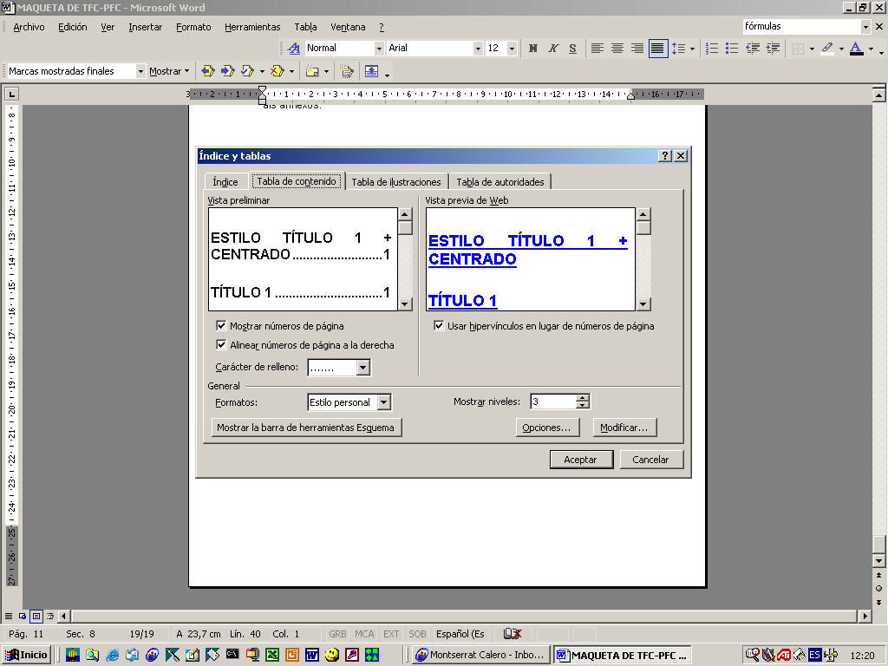

Fig. 2.1 Word menu for the automatic update of the index

* + - 1. Tables

Tables are similar to figures, but the descriptive text is located at the top left corner of the table.

Table 2.1. Model Table

|  |  |  |  |  |
| --- | --- | --- | --- | --- |
| column 1 | column 2 | column 3 | column 4 | column 5 |
| 1 | A | 101 | Z | to |
| 2 | B | 102 | Y | b |
| 3 | C | 103 | X | c |
| 4 | D | 104 | W | d |

* + - 1. Footnotes

For short explanations that are digressing from the main path of the text, used footnotes[1], but please do not abuse.

### Sustainability considerations

Generally this section is linked to the conclusions, except in cases where environmental impact or sustainability considerations are so relevant in the thesis that need more space or a chapter.

Basically it is necessary to elaborate on the economic, social and environmental impacts (positive or negative) of the work done in the thesis, and what can be the possible future impacts in the short, medium and long term.

It is not permitted to say "it had no impact"; albeit small, there is always an impact. For example, the development of software needs hardware that consumes electricity, with the associated economic impact and CO2 emissions.

### Ethical considerations

Generally this section is linked to the conclusions, except in cases where ethical or social impacts are so relevant in the thesis that need more space or a chapter. Think about the possibility that the technology you have developed can have an impact on economy, privacy, human rights, etc.

## Acronyms

A one or two page chapter, with a list of alphabetically-ordered acronyms used in the text and its meaning (not a definition, just the meaning), in two tabulated columns, should be included (typically between Conclusions and Bibliography).

Example:

**ACRONYMS**

NFV Network Functions Virtualization

SDN Software-Defined Networking

## Bibliography / Reference list

The bibliography should be listed in a new chapter, including books and journal articles, numbered in square brackets [1] and in the following format:

* books: Author / s (surname and initials of names), book title (in italics), publisher, city and year of publication. When the appointment chapter of a book should indicate the title of the chapter (in quotes), book title (in italics) and page numbers for the first and last included.

For example:

[1] Hall, JA, "Imaging tubes" None. The 13 Infrared handbook, Wolfe, WW, Zissis, GJ, eds., Pp. 132-176, FYROM, Ann Arora, MI (1978).

* Articles in magazines: Author / s (surname and initials of names), title of the article (in quotes), journal name (in italics) -only abbreviations can be used in well-known magazines - volume number, number of pages the first and last included, and year of publication.

For example:

[2] Bluzer, and N. Jensen, AS "Current readout of infrared detectors" *Opt. Eng.* 23 (3), 241-248 (1987).

Insert references within the body of the work using the numeric references from literature,

For example:

A development of this theory was made by Hall in 1978 (see [1]).

The authors of [23] present a novel network architecture…

## Annexes

In general, annexes include data that would make the text cumbersome and difficulty to read (charts, statistics, tables, results and complementary theoretical developments, etc). On the other hand, constant references to annexes can force the reader can interrupt the reading of the main body of the work. Therefore, you have to reach a trade-off between what is included in the main body or the annexes.

In the event that, with all attachments, the work has a volume of ​​over 100 printed two-sided pages (200 text pages), the annexes must be placed in a volume separate from the main body of the work. This additional volume must start with a cover page where instead of DEGREE THESIS it says ANNEXES and keeps the same structure of title, author, advisor, date, logo, etc.

CONCLUSIONS

Conclusions may not have a chapter number assigned. This chapter should include at least the following sections:

1. Conclusions of your work: a short recapitulation of the work done and your contributions, with critical comments about the results obtained, what has not worked as expected and why, etc. This should have at least one page.
2. Future lines of development and research. What can be done in future works, starting from what you have done. Analyse in detail each proposal, adding references, evaluation of the workload, possible problems that the next student may found, hints (“this could be done in this way”), etc. This should have at least one page.
3. Sustainability considerations (see Section 2.2.4). At least one (long) paragraph.
4. Ethical considerations (see Section 2.2.5). At least one (long) paragraph.

ACRONYMS

NFV Network Functions Virtualization

SDN Software-Defined Networking

REFERENCES

[1] Hall, JA, "Imaging tubes" None. The 13 Infrared handbook, Wolfe, WW, Zissis, GJ, eds., Pp. 132-176, FYROM, Ann Arora, MI (1978).

[2] Bluzer, and N. Jensen, AS "Current readout of infrared detectors" *Opt. Eng.* 23 (3), 241-248 (1987).

1. This is an example of footnote – it should be no more that 2-3 lines